
FACULTY OF ENGINEERING
DEGREE ENGINEERING
DEPARTMENT OF COMPUTER ENGINEERING
SOFTWARE ENGINEERING (BE103505)
Unit-2 –Agile Development
Agility and Agile Process Model

Agility
Agility means being flexible, fast, and ready to accept changes in software development. It encourages teamwork and clear communication between team members, customers, and managers. It focuses on delivering working software quickly instead of spending too much time on documents or plans. It also accepts that plans may change during the project and should remain flexible. Agility can be used in any software development process.

Agile Process
Agility Principles The Agile process is based on some important ideas. First, it is difficult to know in advance which requirements will change, so changes are expected. Second, design and development happen together, meaning software is designed and built at the same time. Third, activities like analysis, design, coding, and testing do not follow a strict order and may change during the project.
Agility Principles
- The main goal is to satisfy the customer by delivering useful software early and continuously.
- Changes in requirements are welcomed, even late in the project.
- Working software should be delivered frequently, in short time intervals.
- Business people and developers should work together every day.
- Teams should be motivated, trusted, and supported to complete their work.
- Face-to-face communication is the best way to share information in a team.
- Good design and technical quality should be maintained continuously.
- Teams should regularly review their work and improve their process.
Agile Process Models:
- Extreme Programming (XP)
• Adaptive Software Development (ASD)
• Dynamic Systems Development Method (DSDM)
• Scrum
• Crystal
• Feature Driven Development (FDD)
• Agile Modeling (AM)

Extreme Programming (XP) – Very Simple
Extreme Programming (XP) is an Agile method used to develop software quickly with good quality.

1. Planning
- Customer writes what they need (called user stories).
- Customer decides which stories are most important.
- Developers estimate the time needed.
- Work is divided into small parts and planned.

2. Design
- Keep the design simple.
- Plan how the software will work.
- Improve the design when needed.

3. Coding
- Write tests before writing the code.
- Then write the code.
- Fix problems early.

4. Testing
- Test each feature automatically.
- Customer checks if the software works as expected.
- Make changes if needed.
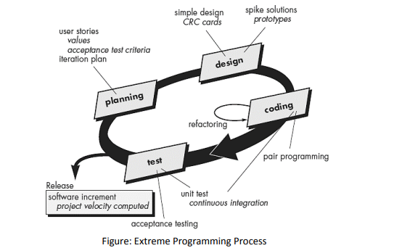

Adaptive Software Development (ASD)
ASD is a software development model used for large and complex projects. It is flexible and accepts changes during development. It has three phases:

1. Speculation (Planning)
- Plan the project with basic goals, not fixed details.
- Accept that requirements may change.
- Focus on understanding what the customer really needs.
- Make flexible plans instead of strict plans.

2. Collaboration (Teamwork)
- Everyone works together: developers, managers, customers, and stakeholders.
- Team members share ideas and solve problems together.
- Plans are updated when requirements change.

3. Learning (Improvement)
- Develop the software in small steps.
- Test the software often.
- Find mistakes early and fix them.
- Learn from feedback and improve the product.
Dynamic Systems Development Methods (DSDM)
The Dynamic Systems Development Method (DSDM) is an Agile software development model. It provides a framework for building systems quickly within tight time limits using incremental prototyping. It follows an iterative approach where each cycle follows the 80% rule, meaning only enough work is done to move forward, and remaining details are completed later when requirements are clearer.

1. Feasibility Study
- Check if the project is possible.
- Find out if DSDM is the right method.
- Check time, cost, and resources.

2. Business Study
- Understand what the business needs.
- Collect the main requirements.
- Plan the basic system structure.

3. Functional Model Iteration
- Build a small working model (prototype).
- Show it to the customer.
- Get feedback and improve it.

4. Design and Build Iteration
- Improve the prototype.
- Add all required features.
- Turn it into a complete working system.

5. Implementation
- Deliver the final software.
- Install and use it in the real environment.
Scrum
The Scrum model is an Agile development method that follows the Agile manifesto. It organizes software development into five main activities: requirements, analysis, design, evolution, and delivery. Work is done in small cycles called sprints, where each sprint completes a part of the project. The Scrum team can change and adjust work during development based on project needs.

Sprint:
- A sprint is a short time period where a small part of the work is completed.
- The number of sprints depends on the size and complexity of the project.
- Each sprint focuses on completing specific tasks and can be adjusted as needed.

Backlog:
- A backlog is a priority list of features or requirements for the project.
- It contains all tasks that provide value to the customer.
- New requirements can be added at any time.
- The product manager updates and manages the priority of backlog items.

Key Idea:
- Scrum is useful for projects with changing requirements and tight deadlines.
- It helps teams deliver working software step by step with continuous improvement.

Crystal
The Crystal methodology is a lightweight and flexible Agile software development approach. It is actually a family of methods such as Crystal Clear, Crystal Yellow, Crystal Orange, etc., and each method is chosen based on factors like team size, project importance, and complexity.
Crystal understands that every project is different, so it allows teams to adjust their processes, rules, and practices according to the project needs.
It focuses mainly on teamwork, good communication, simplicity, and continuous improvement. The team regularly reflects on their work and improves the process whenever needed.
Like other Agile methods, Crystal supports frequent delivery of working software, active customer involvement, flexibility to changes, and reducing unnecessary processes or paperwork.

Feature Driven Development (FDD)
- FDD is an Agile method.
- Software is built feature by feature.
- A feature is a small function for the user.
- First, make the system plan.
- Then build one feature at a time.
- Test each feature before adding it.

Agile Modeling (AM)
- AM is a simple way to make models.
- Create only useful documents.
- Avoid unnecessary paperwork.
- Keep models simple and easy.
- Change the model if needed.

